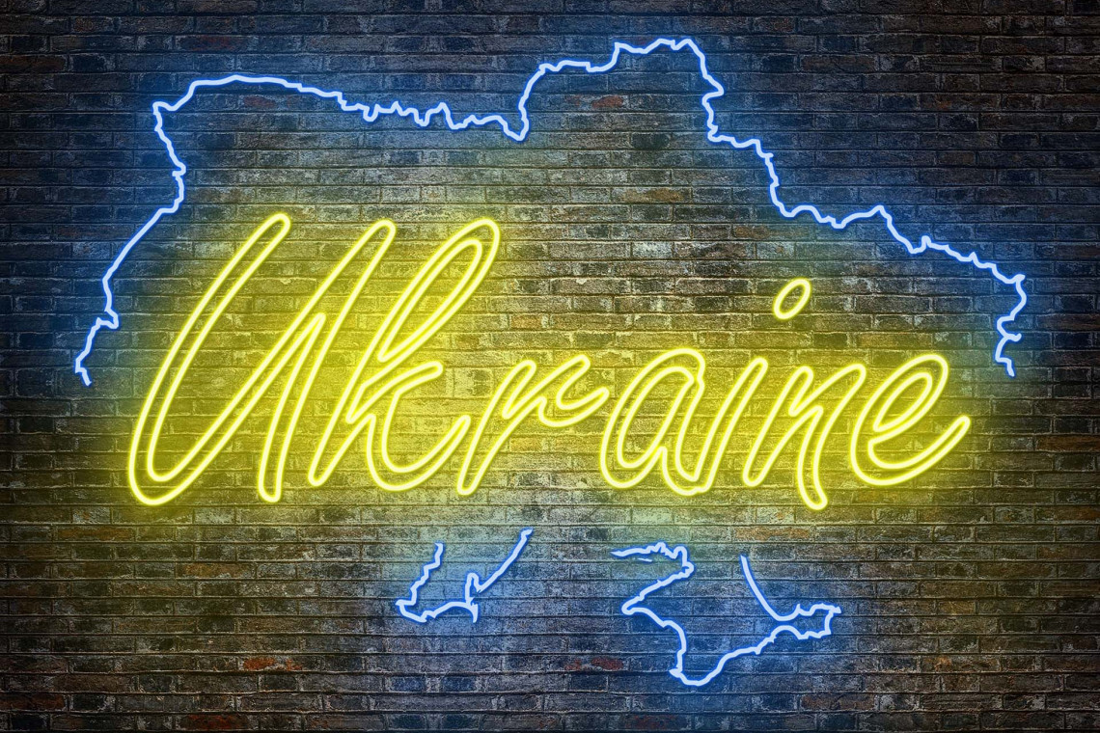

**Newsletter no: 5 from Ukraine Café Gemert-Bakel.**

Dear people.

The weather has been warm in Gemert-Bakel for weeks, but the Ukraïne Café has no summer holiday closures. The six volunteers will keep the Café open in the coming period, and fortunately more and more Ukrainian refugees and organizations are finding their way to De Refter, Hof van Nazareth 53. People come there to meet each other, ask questions, share experiences and certainly also to get away from the daily grind.

We have received a message from the welfare work of the LEV group Laarbeek that Ukrainian refugees, who live in the monastery in Aarle-Rixtel, are going to visit our Café. The more the merrier.

In even weeks we are open on Wednesday from 2:00 pm to 4:30 pm and in odd weeks on Friday from 10:00 am to 12:30 pm. Coffee and tea are available and free.

There are snacks and toys for children available.

**Soup.**

In Ukraine, people know very well that the way to a guest's heart is through the stomach. That is why we are going to make a pumpkin-tomato soup for the guests of the Ukraïne Café on 19 August. We serve these together with bread at the end of the meeting.

**English and Dutch lessons.**

The Ukraine Café is looking for Ukrainian refugees who want to learn English. Zoriana, one of the refugees, speaks English well and is eager to teach the language to others.

The Ukraine Café is also looking for volunteers who can help Ukrainians living in Gemert-Bakel to learn the Dutch language. A Ukrainian interpreter is available for support.

After the holidays, the Language Café in the Library, St. Annastraat 60, will open again on Thursdays from 9.30 – 11.30 am.

**Toddler Library**  
On September 21, De Lage Beemden Library will start a toddler library in collaboration with the village supporters of Gemert Center. While somebody reads stories tot the toddlers, mothers can drink coffee or tea together from 9.30 to 10.30 in the library in “De Eendracht”, St. Annastraat 60.

**Looking for work.**  
As a job seeker you can contact Activus, Ridderplein 31 or Senzer, Churchilllaan 109 in Helmond. They also know everything about the conditions, insurance, etc.

**Activities in Gemert-Bakel and surroundings**:  
13 August Guided tour of the Historic Center via the Tourist Office – 11 a.m.

15 August Oldfashioned Harvest Day, Mutshoek in Boekel.

19/20 August Zebra Festival JC De Bunker – free entrance.

19/21 August Elsendorp summer parties.

21 August Art market Gemert and Flea market Koks Gemert.

27 August Guided tour of the Historic Center via the Tourist Office – 11 am.

27&28 August Beach volleyball on Ridderplein.

3 September Guided tour of the Castle 11.00 am VVV Ridderplein.

10 September Open Monument Day - Guided tour of the center and Castle.

11 September Gemert Mert – shops and castle park open.

16/20 September Autumn fair Schabbert + music Ridderplein.  
 **Walking and cycling**  
For those who like walking or cycling, there are routes in Gemert-Bakel and surroundings at the VVV on Ridderplein. Often free, sometimes for a small fee. The tourist office is open every day. Monday from 1:00 PM to 4:30 PM, Tuesday to Friday from 10:00 AM to 4:30 PM and Saturday from 10:00 AM to 2:00 PM.

**Sports/fitness.**If you want to play sports or fitness, you can go to various addresses:

0 Fitland, Vic. Van Asdonkstraat 55, Gemert.

0 Fitclub, Weerijs 10, Gemert

0 Boxfit, Nijverheidsweg 11, Gemert

0 Crossfit, Straight run 10, Gemert

0 Prime Gym, Wolfswater 9E, Gemert

0 Fit+Gemert, Haageijk 11, Gemert

0 EMC, Gelind 28, Gemert

0 N0.1 , Fitness, the Brakken 1, Bakel

0 EMC, St. Wilbertsplein 8, Bakel

0 Your Body Only, Bolle Akker 9, Bakel  
You can contact the various sports associations for football, tennis, swimming and handball. If you want the contact address of a sports association, ask the village supporters or one of the volunteers during the Ukraïne Café.

**Thrift store and give-away-shop**There are several thrift shops (kringloopwinkels) in Gemert and surroundings where you can buy second-hand furniture, kitchenware, clothing, white goods, etc. for little money. There is also a giveaway shop in Gemert. Here are some addresses:

• Thrift shop, Noorddijk 2, Helmond

• Cardoso, 231 Engelsweg, Helmond

• Platform 3 (Salvation Army) Landing 48a, Helmond (clothing)

• De Florijn, De Vlonder 47, Boekel

• Stg. Minima, Industrieweg 66, Gemert

• Znuffel, Speelweide, Bakel (clothing only)

• Kringloop Uden, Loopkantstraat 25b, Uden

• ONA (large assortment + lots of clothing), Industrielaan 8, Asten

• Een Aarde (good shop, the proceeds go to developing countries), Molenakkers 11, Asten

• Nieuw Begin, Willemstraat 7, Beek en Donk (lots of clothing)

Giveaway shop:

• Deken van den Heuvelstraat 69, Gemert (Saturday 11-12 am, 0683617000

• Clothing bank (kledingbank): you need a referral letter from the village supporters. The clothing bank can be found at Molenrand 9 in Gemert [www.kledingbank-gemert.nl](http://www.kledingbank-gemert.nl/) Due to holidays, the clothing bank has adjusted opening hours.

**Gifts from communicants and confirmands of the St. Jansparochie.**On behalf of these children, Joke van Oort handed out backpacks with gifts among the children of Ukrainian refugees. The gifts have been very well received. On behalf of the Ukrainian refugees and certainly on behalf of the children, many thanks again.

If you have any questions or comments regarding this newsletter, please let us know.

On behalf of the volunteers - Angela, Ineke, Thea, Jannie and Vera - we wish you a good summer in Gemert-Bakel.

Houdoe and goodbye,

Léon van Dijck

0616267071